Exp. 2 Design Christmas dual led chaser lights.

Circuit Diagram:

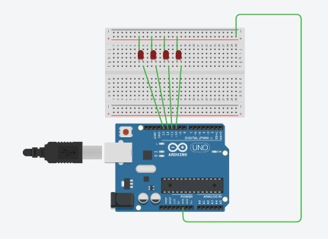

Theory: 555 timer IC. The 555 timer IC is

an integrated circuit (chip) used in a variety of timer, pulse generation, and oscillator applications. The 555 can be used to provide time delays, as an oscillator, and as a flip-flop element. Derivatives provide two (556) or four (558) timing circuits in one package.

Learning & Observation:

1.Working of LED chaser.

2.Code for Arduino to Run LED Chaser.

Precautions:

1.There should not be any loose connection in the circuit.

2.Code should be written properly.

3.Arduino should be attached to pc/laptop properly.

Code:

void setup(){

// se ng up output pins

for (int i = 10; i <= 13; i++) { pinMode(i, OUTPUT);

}

} void loop(){

for (int i = 10; i <14; i++) { allLEDsOff(); if (i!=13){ digitalWrite(i,HIGH); digitalWrite(i+1,HIGH); delay(200);

}

else digitalWrite(i,HIGH); digitalWrite(i-3,HIGH); delay(200); allLEDsOff();

}

}

void allLEDsOff(void)

{ for (int i = 10; i <= 14; i++) { digitalWrite(i, LOW);

}

delay(100);

}